Ideation Phase
Brainstorm & Idea Prioritization Template

Date | 20 February 2026
Team ID | LTVIP2026TMIDS66114
Project Name | Smart Sorting
Maximum Marks | 4 Marks

Brainstorm & Idea Prioritization Template:
The team conducted a brainstorming session to identify real-world problems that can be solved using artificial intelligence and deep learning. Several problem areas were discussed, including food waste management, quality control in agriculture, and automation in food processing industries. The team identified that manual sorting of fruits and vegetables is time-consuming, inefficient, and prone to human error. Rotten produce often goes undetected, leading to quality issues and increased food waste. Therefore, the team selected the problem statement of developing an intelligent smart sorting system using transfer learning to automatically identify rotten fruits and vegetables.
Reference: https://www.mural.co/templates/brainstorm-and-idea-prioritization
Step-1: Team Gathering, Collaboration and Select the Problem Statement
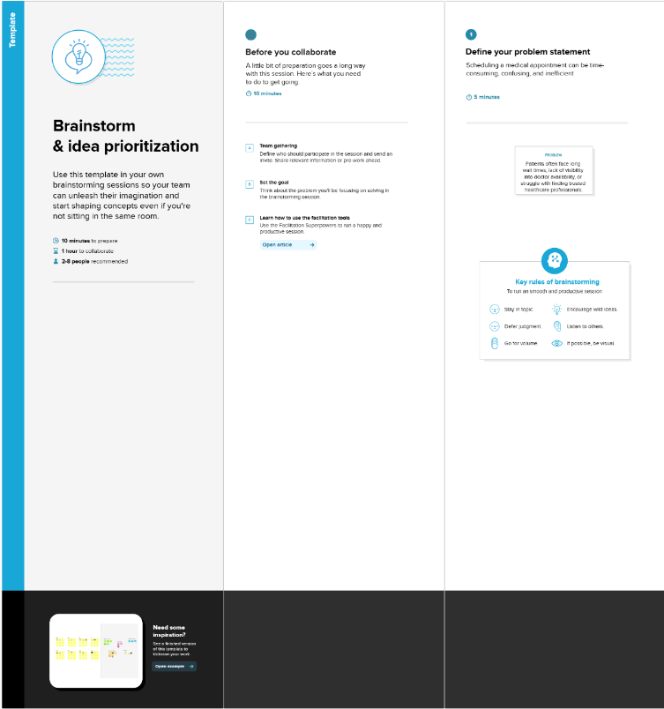
Step-2: Brainstorm, Idea Listing and Grouping
During the brainstorming session, multiple ideas were generated and discussed. These included using image processing to detect fruit quality, developing a mobile application for freshness detection, creating a smart refrigerator system, and building an automated sorting system for industries. The ideas were grouped based on feasibility, impact, and technical implementation. The team decided to focus on an automated image classification system using transfer learning, as in provides high accuracy, real-time detection, and practical applications in industries, supermarkets, and smart homes.
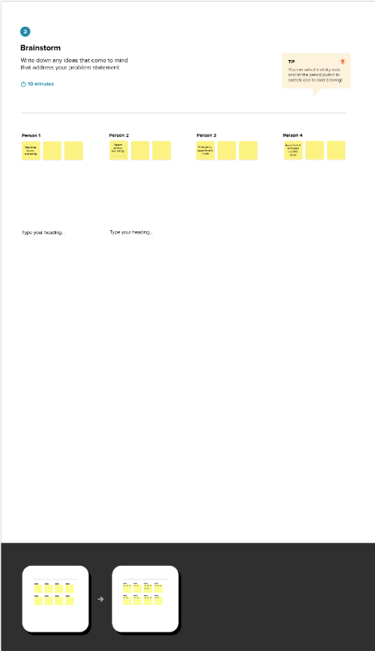
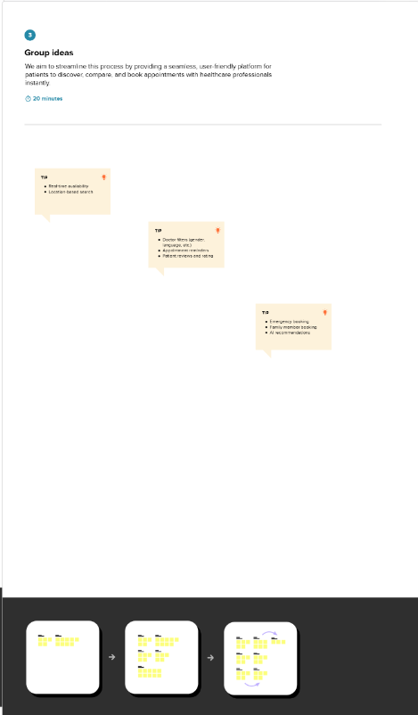

Step-3: Idea Prioritization
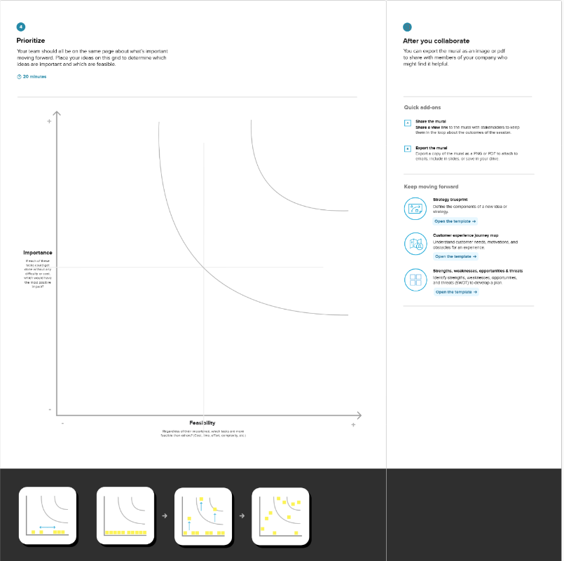
The team evaluated the proposed ideas based on criteria such as feasibility, innovation, real-world impact, and implementation complexity. The smart sorting system using transfer learning was prioritized because it offers an efficient solution for detecting rotten fruits and vegetables, reduces manual effort, minimizes food waste, and improves quality control. The availability of pre-trained deep learning models and datasets makes the implementation feasible. Therefore, this idea was selected as the final project for development.

